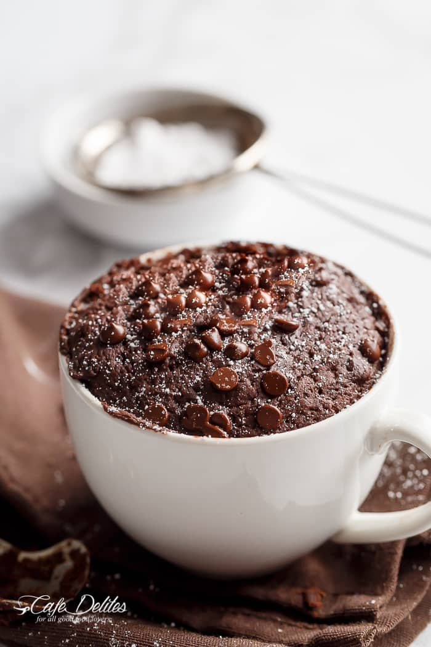Low Fat Chocolate Mug Cake

**Prep Time**

1 min

**Cook Time**

1 min

**Total Time**

2 mins

**Weight Watchers Smart Points:** 3 *without* chocolate chips | 6 *with* chocolate chips

Servings: [1](https://cafedelites.com/low-fat-chocolate-mug-cake-recipe/)

Calories: 138 kcal

Author: Karina - Cafe Delites

**Ingredients**

* 2 tablespoons (1 oz | 30 g) self raising flour
* 1 tablespoon natural granulated sweetener to keep calorie count low (if white, raw or coconut sugar, and counting your calories, remember to add this in)
* 2 level teaspoons unsweetened cocoa powder for a mild chocolate cake OR 1 tablespoon for a darker , richer chocolate cake
* 1/4 teaspoon baking powder
* pinch of salt
* 1 teaspoon reduced fat butter , melted (or coconut oil)
* 2 tablespoons (40ml) unsweetened almond milk (or skim milk for an extra point) *2 1/2 tablespoons of milk if using 1 tablespoon cocoa powder
* 1/8 teaspoon pure vanilla extract
* 3/4 tablespoon mini chocolate chips of choice (milk or dark), divided *optional (See Notes)

**Instructions**

1. Grab a 1/2-cup capacity mug and spray with cooking oil spray. Into the mug, add in the flour, sweetener (or sugar), cocoa powder, baking powder and salt. Whisk to combine. To that, add your melted butter, milk and vanilla.
2. (Optional): Fold in 1/2 tablespoon of chocolate chips. Mix them through. Top with the remaining chocolate chips.

**Minute Microwave Method:**

1. Bake in your microwave on 'Quick' or High' setting for 40 seconds. Open the door and gently touch the top with your finger tip. If it's still a little underdone in the middle, bake for another 10 seconds until cooked through (not too long, as the cake will continue cooking in the mug once it's removed).

**Oven Baked Version:**

1. Preheat oven to 180°C | 350°F. Spray a 1/2-cup capacity ramekin with cooking oil spray. Prepare as above and bake in the oven for around 15 minutes, or until a toothpick inserted into the centre comes out clean. (For a fudgier cake, check it after 11 minutes with a toothpick and it should come out slightly dirty, but not with a lot of cake batter attached.)
2. Serve with fruit, icing sugar, ice cream, or whipped cream! Personally, I like this cake on its own.

**Recipe Notes**

*Adding the chocolate chips makes this 219 calories |5g Protein | 8g Fat | 33g Carbs | 3g Fiber |